FOR SALE
13 HONISTER DRIVE, BORROWDALE, HARARE
A RARE OPPORTUNITY TO ACQUIRE A PRIME RESIDENTIAL SITE WITH RIGHTS TO DEVELOP 8 CLUSTER HOMES IN AN UPSCALE LOCATION

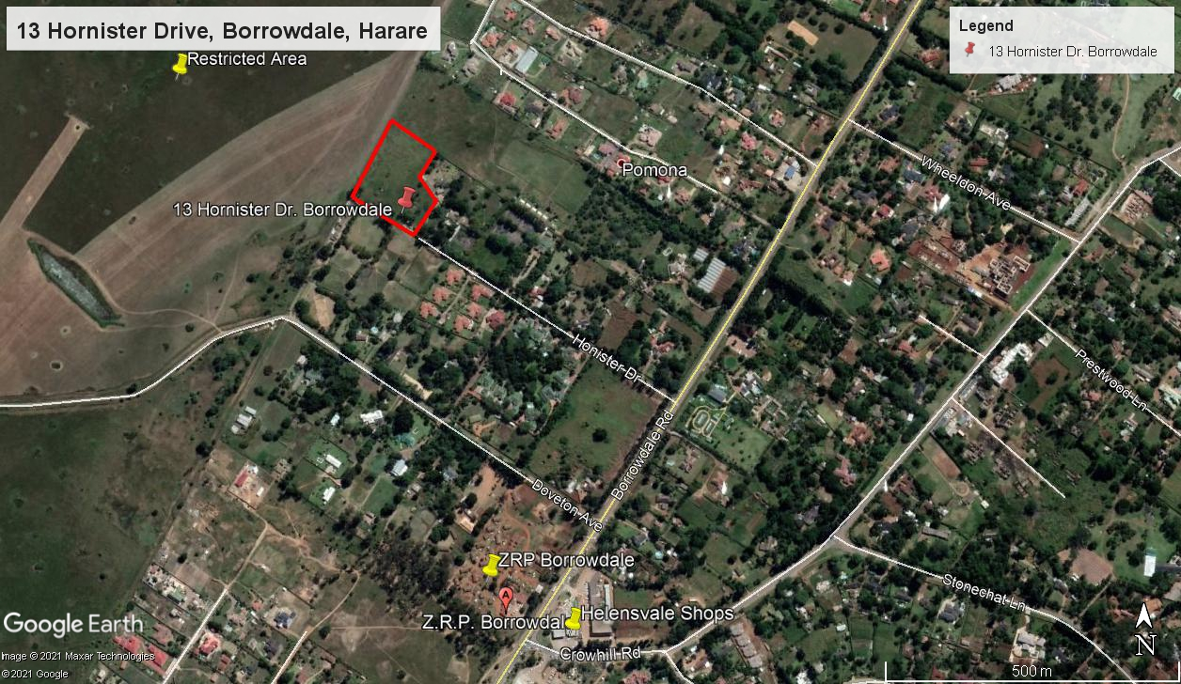
- Well located at the end of a Cul de Sac
- Easily accessible from the important Borrowdale Road trunk route
- 1.7758Ha in extent
- 5 minutes driving time to the preeminent Sam Levy’s Village regional shopping centre
A price of US$350,000 is required for this exciting opportunity
For an appointment to view contact Nancy Machemedze on +263 77 578 0169 (nmachemedze@dawnconsult.co.zw) or John Kondo on +263 78 549 9707 / 71 352 2822 (jkondo@dawnconsult.co.zw)

1. Location
The property is situated 14 kilometres to the north of the Harare CBD and a 5 minute drive from the Sam Levy’s Village Shopping Centre in the prestigious Borrowdale suburb. The highly regarded Old Plantation cluster housing scheme is close by while a local shopping centre with a Spar supermarket is a short walk away. Top end schools including Heritage School and St Johns College are within a 7 kilometre radius.
2. Title Information
Legal description : Remainder of Subdivision A of Stand 11 of Lot C of Borrowdale Estate
Registered Owner : Windspike Investments (Private) Limited
Deed Number : 3709/2010 dated 4 August 2010
Land Area : 1.7758 Hectares

*The title is free of encumbrances, caveats or endorsements.
3. Town Planning
The property falls within the Greater Harare Planning Authority jurisdiction and is zoned for Residential Use under the Mazowe Local Development Plan.

3.1 Freely Permitted Uses:
- Detached Dwelling Houses

3.2 Uses Permitted By Special Consent:
- Cluster Homes
- Residential buildings;
- Residential Buildings (Institutional);
- Schools and residential colleges;
- Crèches;
- Surgeries;
- Public buildings;
- Place of worship;
- Places of assembly;
- Newspaper offices; and
- Funeral parlours.
*The property has an expired development permit to construct 8 cluster homes which requires renewal.
4. Services
The site is served by:
4.1 City of Harare mains water; and
4.2 ZESA electricity.
*There is an unfitted borehole on the property.
5. Possession

Vacant possession is available on registration of transfer of title.

6. The Offer

The Vendor is offering the freehold title to the property for a price of US$350,000.00. Signature of the Agreement of Sale is subject to the deposit of the full purchase price into Vendor’s nominated bank account. The property is being sold voetstoots and as it stands.

8. Investment Rationale
- A unique opportunity to acquire a strategic site suitable for development into a high end cluster homes;
- The property falls within an established cluster housing zone; and
- Well designed and constructed cluster homes in strong locations have over the past few years outperformed competing property assets both in terms of rent income and capital growth.
Contacts
For further information and viewing arrangements please contact John Kondo on +263 78 549 9707 / 71 352 2822 jkondo@dawnconsult.co.zw or Nancy Machemedze on +263 77 578 0169 nmachemedze@dawnconsult.co.zw.
Disclaimer
All care has been taken in preparing the information contained in this document. However, it is the responsibility of any prospective purchaser to verify the information or consult its advisors before making a binding offer. Neither Dawn Property Consultancy (Private) Limited nor its representatives can be held accountable for the accuracy of the information contained herein.

